

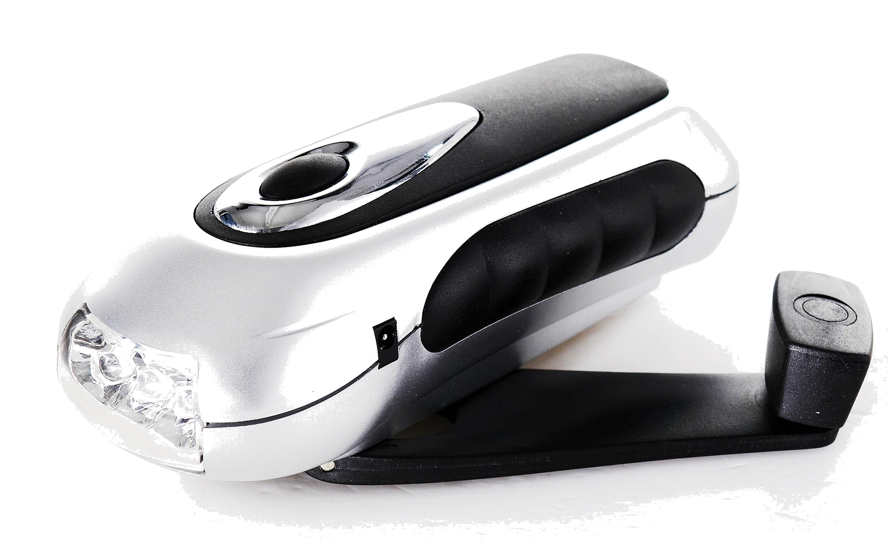



EG-PC-002 hand charger
for mobile phones with flashlight
USER MANUAL

Disclaimer

We spared no efforts to make sure that the information in this manual is correct and complete. However no liability is accepted for any errors or omissions. Gembird Electronics reserves the right to change the specifications of the hardware and software described in this manual without prior notice.
No part of this manual may be reproduced, transmitted or translated in any language in any form, by any means, without the prior written permission of Gembird Electronics Ltd.
Gembird Electronics makes no warranties for damages resulting from corrupted or lost data due to a mistaken operation or malfunction of the product, the software, personal computers or peripheral devices.

Energenie® is a registered trademark of Gembird Europe bv.

Other names or products not mentioned above may be registered trademarks or trademarks of their respective owners.

Copyright © 2010 Gembird Electronics Ltd. All rights reserved

Features
- Clean crank dynamo energy: no need to have extra battery or power source!
- Rotate the handle for 2 minutes to charge your mobile phone for at least for 1-4 min conversation
- Rotate the handle for 1 minute to power up the super-bright flashlight torch for at least 30 minutes
- LEDs instead of bulbs, high-quality switch, water-resistant design guarantee a very long product life

Specifications

- Output: 4.5...6.5VDC up to 400mA
- Battery built-in: Ni-MH, rechargable 80mAH, lifetime at least 500 full recharging cycles
- The super-bright torch: 3 LEDs of total brightness 50000mCd
- Supports mobile phones: Nokia 6101 and 8210 series, Samsung A288 series, Blackberry/HTC Mini USB 5pin connector, Sony Ericsson K750 series, Micro-USB
- Dimensions: 140x54x52mm
- Net weight: 0.18kg
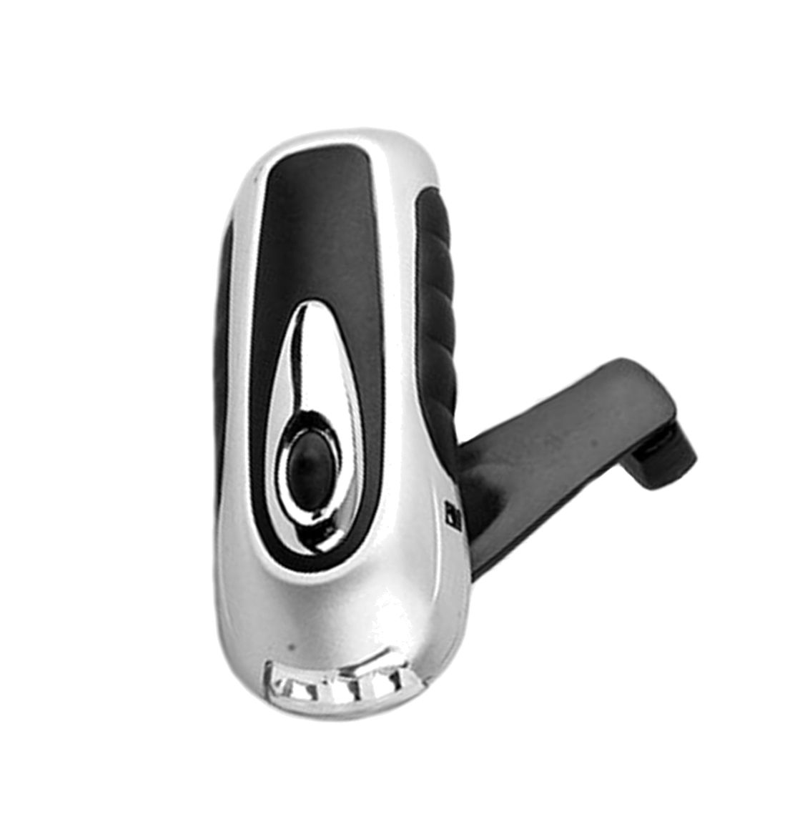
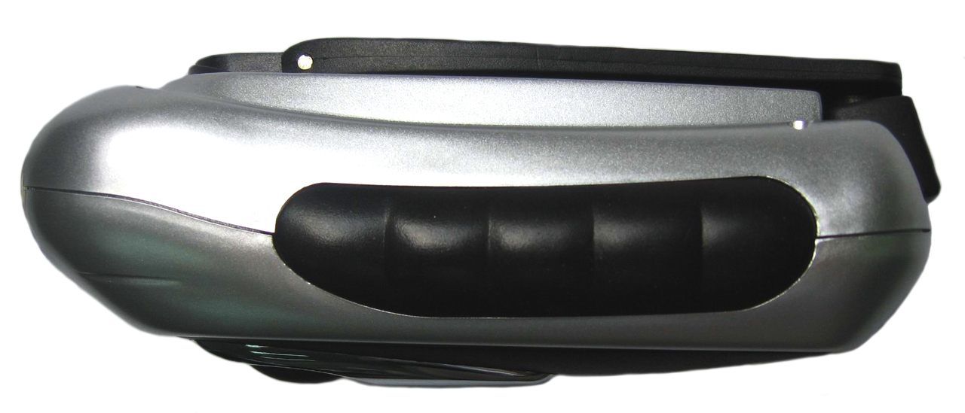

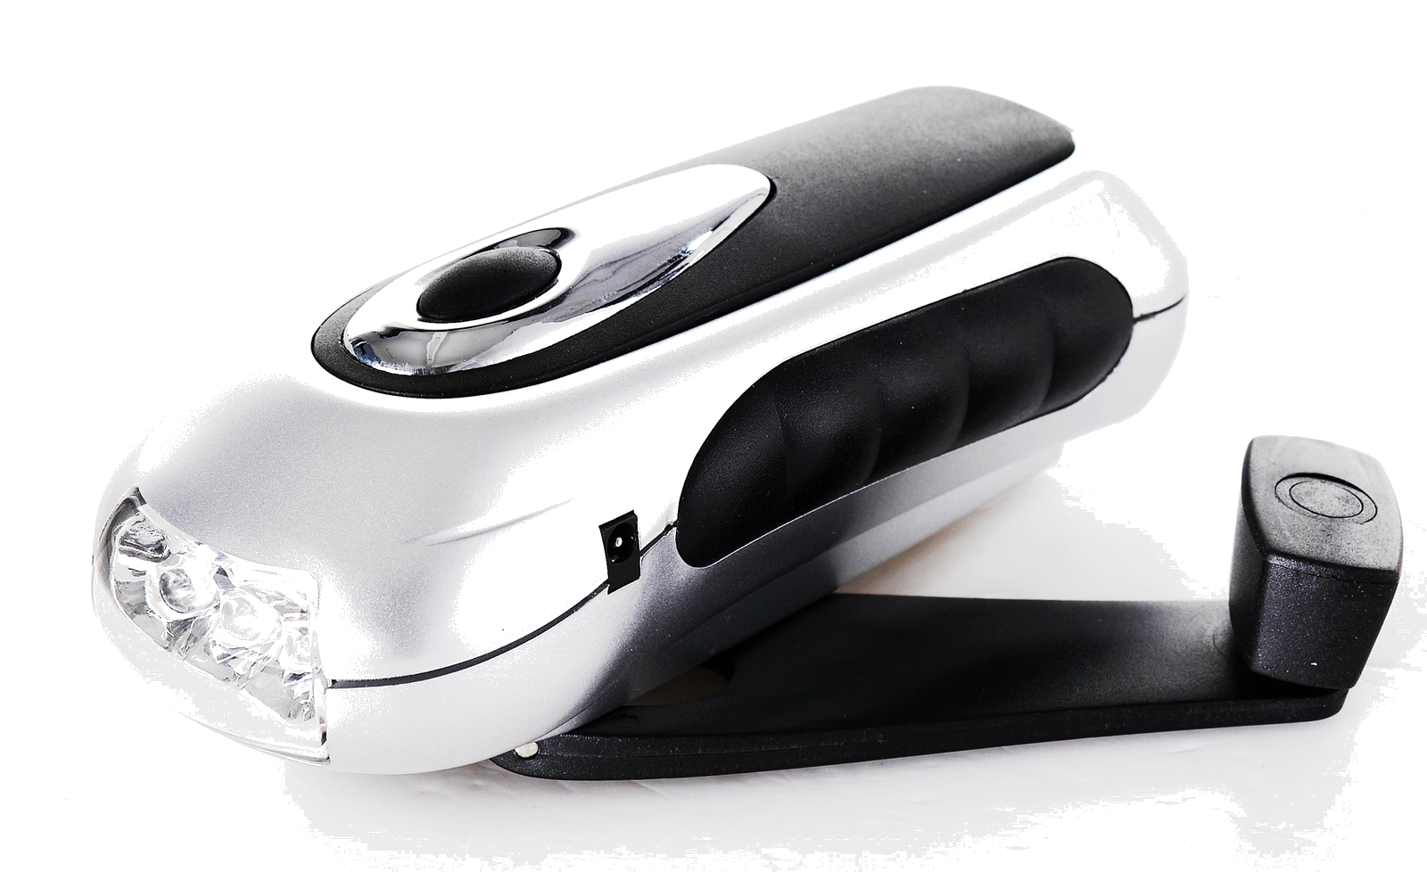
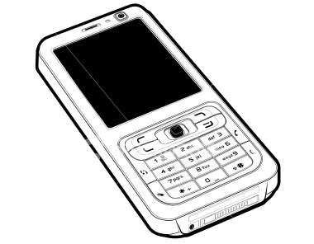
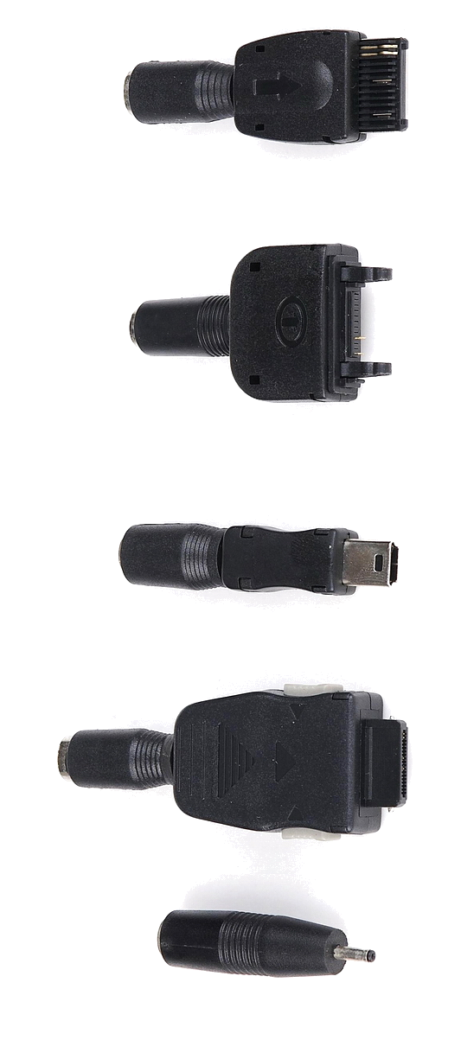
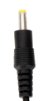

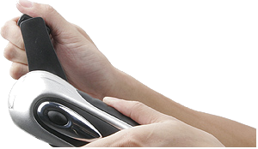
~

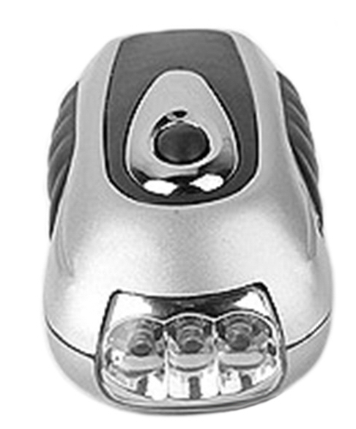
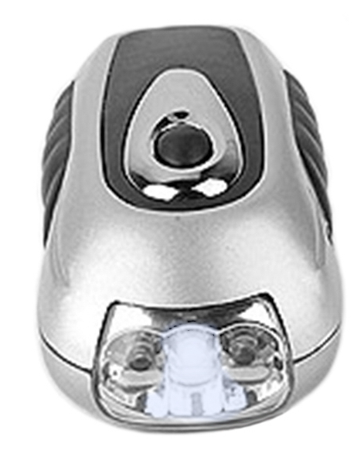
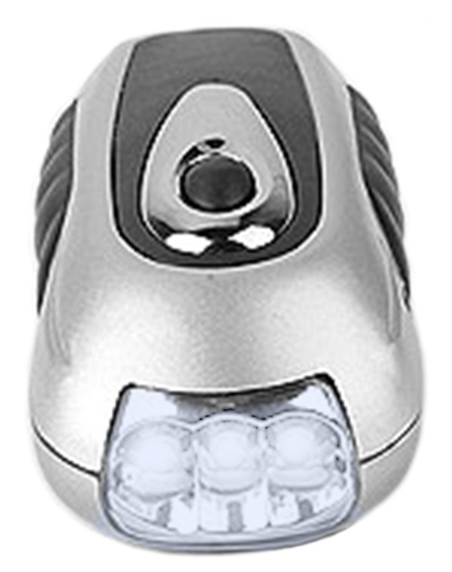
1
2
4
3

